CAMPBELLTOWN CITY COUNCIL
PROPOSED COMMUNITY RECYCLING CENTRE
HEPHER ROAD CAMPBELLTOWN
DA 2117/2019

WASTE MANAGEMENT RESPONSE TO SEAR’s 1251

INTRODUCTION
The following response has been prepared to address the Waste Management requirements of the SEAR number 1251 dated 14 September 2018.
Community Recycling Centres (CRCs) are permanent drop-off centres for common household problem wastes that can’t be collected via council kerbside waste and recycling collection services. NSW householders can drop off problem wastes at these centres year round, free of charge. Funding for CRC’s comes from the Section 88 PoEO Waste Levy under the Waste Less Recycle More initiative.
Only household quantities of these materials will be accepted at a CRC and as a guide, this is a maximum container of 20 litres or 20 kilograms for each waste type.
Community Recycling Centres complement the Household Chemicals Cleanout program. Any resident presenting chemicals for disposal at the CRC will be directed to the next annual free Household Chemicals Cleanout Event held during April each year at Council’s waste depot in Junction Road Leumeah.
Details of the type, quantity and classification of waste to be received at the site.
Only household quantities of waste will be received at the facility and volume estimates and collection frequencies are shown in Table 1.

Table 1 – Typical quantities of materials anticipated for the Hepher Road CRC serving 160,000 people and estimated collection frequency

MATERIAL | QUANTITY  (t/yr) | QUANTITY (kg/wk) | COLLECTION FREQUENCY (weeks)
Batteries – household | 0.224 | 4 | >52
Batteries – lead | 29 | 557 | 5.3
Fire extinguishers | 0.5 | 9.6 | 17.3
Fluorescent tubes | 2.3 | 44.2 | 17.3
Gas cylinders – LPG and Propane | 11.5 | 221 | 17.3
Oil | 27.5 | 529 | As required
Paint – water based | 96 | 1846 | As required
Paint – oil based | 61 | 1173 | 2.1
E-waste | 52 | 1000 | As required
TOTAL | 228 | 4,383

NOTES:
- The collection contractor will remove all full or near full receptacles at each pick up.
- Quantities will be monitored to determine the most appropriate collection frequency.

The types of waste will include materials that are classified as hazardous albeit in small quantities. As hazardous wastes are to be temporarily stored at the premises, the requirements of the NSW Workplace Health and Safety Regulation 2011 are applicable. The Regulation provides for the safe use, storage and handling of chemicals classified under the UN Globally Harmonised System of Classification and Labelling of Chemicals (GHS).
Some requirements of the Regulations are only relevant where quantities stored exceed specific levels. These placard and manifest quantities for materials stored at CRC’s are outlined in the Figure below. The classification of these materials under the Australian Dangerous Goods Code (ADGC) and the GHS are also shown.

Table 2 – Placard and manifest quantities for materials stored at CRC’s
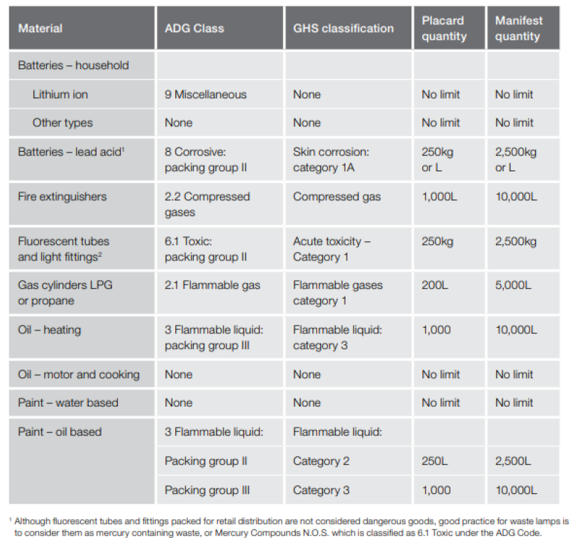

Details of the resource outputs and any additional processes for residual waste.
Any residual (by-catch) wastes received at the facility being of an inert non-hazardous nature will be immediately placed into one of several 240 Litre mobile garbage bins fully self-contained and ready for collection by Council’s rear loading waste compaction vehicle. This material will typically conform to a “General Waste (non-putrescible)” waste classification under the NSW Waste Classification Guidelines issued by the NSW Environment Protection Authority.
The material will initially be transported for disposal at a Class II non-putrescible waste disposal facility such as Glenfield Waste for example, which is licensed to accept and dispose of non-putrescible waste.
In the event a waste processing facility becomes available to process non-putrescible waste into for example renewable energy, Council would direct the residual waste be transported to that facility for processing and conversion into a renewable energy product.
For any by-catch material of a hazardous nature, these will be placed directly into separate dangerous goods safety cabinets compliant with the relevant Australian Standard for flammable, oxidising, toxic and corrosive materials.
Details of waste handling including transport, identification, receipt, stockpiling and quality control.
A staff member will greet each vehicle arriving to unload material at the CRC. This initial screening will ensure that materials are inspected prior to unloading, only target materials are received, and that containers are suitably sealed and not leaking or damaged.
The facility will have procedures in place to ensure that customers deliver only target materials and that these materials are handled by customers and staff in a safe and secure manner. Materials will be separated into different areas in a manner appropriate for compliant storage and ease of loading for transport. Please refer to the Waste Management Plan prepared by Campbelltown City Council for further information.
A forklift will be permanently held on site to change over receptacles, move receptacles to and from the storage area, and to load the collection contractor’s vehicle.
The NSW EPA establishes and maintains contracts for the collection and recycling (or disposal) of paint, used oil (other than motor oil), gas cylinders, household batteries, smoke detectors and fluorescent lights as well as by-catch material. Council is required to arrange for the collection, transport and recycling of lead acid batteries, used motor oil and E-waste.
The measures that would be implemented to ensure that the proposed development is consistent with the aims, objectives and guidelines of the NSW Waste Avoidance and Resource Recovery Strategy 2014-21.
The NSW Government through the EPA released a major funding extension package in 2017 specifically to assist councils, business and communities meet the targets contained in the NSW Waste Avoidance and Resource Recovery Strategy 2014-21. Specifically, $57M of the $331M total funding package was allocated for infrastructure, education and equipment to manage Household Problem Wastes. Campbelltown City Council successfully applied for a grant to establish a CRC within the local government area.
The proposed development is considered to be consistent with the aims and objectives of the NSW Waste Avoidance and Resource Recovery Strategy 2014-21 through development of a dedicated facility located within the LGA designed to target Household Problem Wastes and divert such materials from landfill. The facility may also have the added benefit of reducing the illegal dumping of these materials in the environment.
Please refer to Section 3.7.4 of the Environmental Impact Statement for this proposed development prepared by Premise NSW, which also addresses this issue.

END
27/2/2020

Household Chemical Clean Out events are held annually and are arranged by the NSW EPA; an approved EPA contractor operates the event at Council’s site.
Refer Table A1.1(b) NSW Community Recycling Centres, Operations and management handbook - 2nd edition p.25
Further information is available via accessing the following link https://www.epa.nsw.gov.au/your-environment/recycling-and-reuse/waste-less-recycle-more.

